Loughries Integrated Primary School

Art Gallery Afternoon
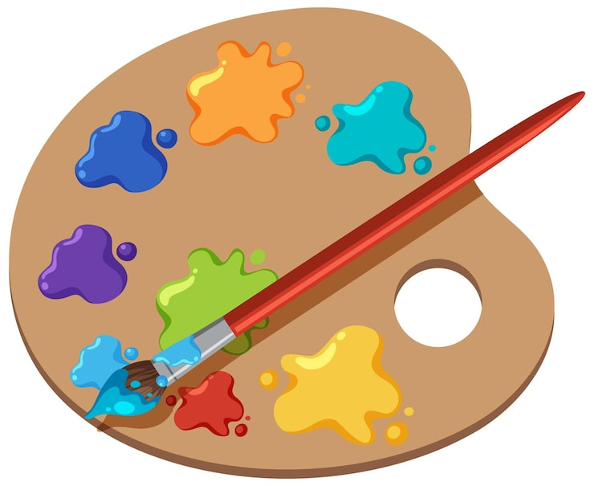

Our children have been working very hard to create some wonderful pieces of art.
Please come along to help us celebrate the work of our budding, young artists!
Wednesday 19th November
2:00pm – 3:30pm in our Canteen
All artwork can be purchased for £5 each and any money raised will be used to purchase new school resources.

